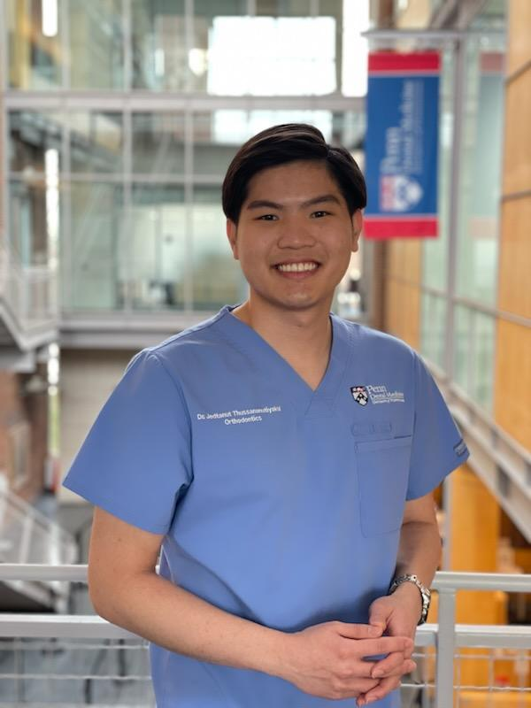

Jedtanut Thussananutiyakul, D.D.S – Penn Dental DScD Student and Ortho Resident.

Jedtanut Thussananutiyakul is a first-year Doctor of Science in Dentistry (DScD) and Orthodontics resident in the School of Dental Medicine at the University of Pennsylvania. He graduated from Chulalongkorn University, Bangkok, Thailand as a Doctor of Dental Surgery. He is interested in researching to gain more insights into oral biology and enhance new relating treatments.